Binary search tree (BST) is a special kind of binary tree where each node contains-

* Only larger values in its right subtree.
* Only smaller values in its left subtree.

**Binary Search Tree Operations-**

Commonly performed operations on binary search tree are-

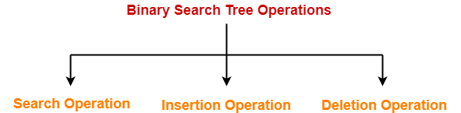

1. Search Operation
2. Insertion Operation
3. Deletion Operation

**1. Search Operation-**

|  |
| --- |
| Search Operation is performed to search a particular element in the Binary Search Tree. |

**Rules-**

For searching a given key in the BST,

* Compare the key with the value of root node.
* If the key is present at the root node, then return the root node.
* If the key is greater than the root node value, then recur for the root node’s right subtree.
* If the key is smaller than the root node value, then recur for the root node’s left subtree.

**Example-**

Consider key = 45 has to be searched in the given BST-

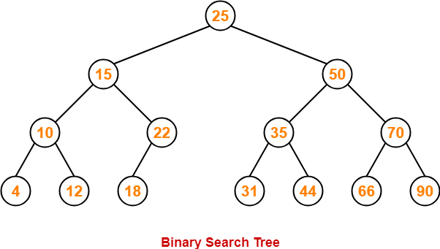

* We start our search from the root node 25.
* As 45 > 25, so we search in 25’s right subtree.
* As 45 < 50, so we search in 50’s left subtree.
* As 45 > 35, so we search in 35’s right subtree.
* As 45 > 44, so we search in 44’s right subtree but 44 has no subtrees.
* So, we conclude that 45 is not present in the above BST.

**2. Insertion Operation-**

|  |
| --- |
| Insertion Operation is performed to insert an element in the Binary Search Tree. |

**Rules-**

The insertion of a new key always takes place as the child of some leaf node.

For finding out the suitable leaf node,

* Search the key to be inserted from the root node till some leaf node is reached.
* Once a leaf node is reached, insert the key as child of that leaf node.

**Example-**

Consider the following example where key = 40 is inserted in the given BST-

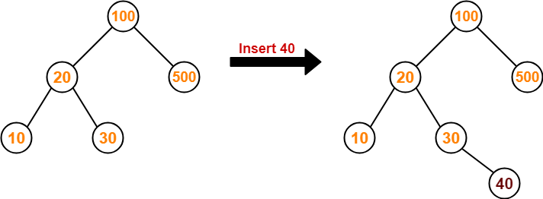

* We start searching for value 40 from the root node 100.
* As 40 < 100, so we search in 100’s left subtree.
* As 40 > 20, so we search in 20’s right subtree.
* As 40 > 30, so we add 40 to 30’s right subtree.

**3. Deletion Operation-**

|  |
| --- |
| Deletion Operation is performed to delete a particular element from the Binary Search Tree. |

When it comes to deleting a node from the binary search tree, following three cases are possible-

**Case-01: Deletion Of A Node Having No Child (Leaf Node)-**

Just remove / disconnect the leaf node that is to deleted from the tree.

**Example-**

Consider the following example where node with value = 20 is deleted from the BST-

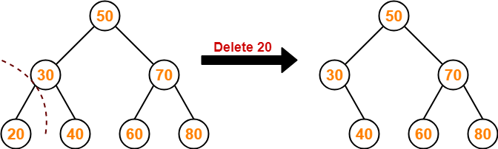

**Case-02: Deletion Of A Node Having Only One Child-**

Just make the child of the deleting node, the child of its grandparent.

**Example-**

Consider the following example where node with value = 30 is deleted from the BST-

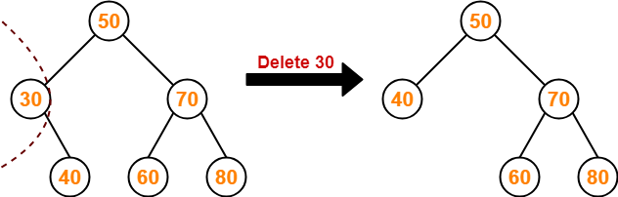

**Case-02: Deletion Of A Node Having Two Children-**

A node with two children may be deleted from the BST in the following two ways-

**Method-01:**

* Visit to the right subtree of the deleting node.
* Pluck the least value element called as inorder successor.
* Replace the deleting element with its inorder successor.

**Example-**

Consider the following example where node with value = 15 is deleted from the BST-

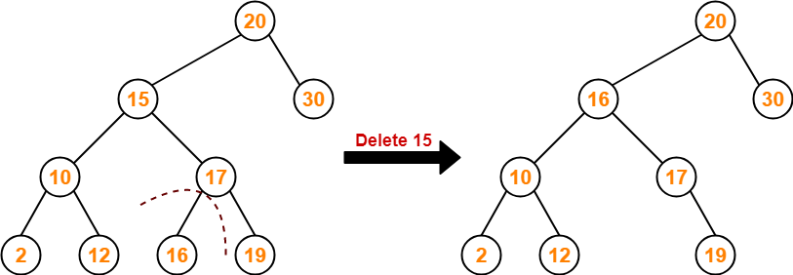

**Method-02:**

* Visit to the left subtree of the deleting node.
* Pluck the greatest value element called as inorder predecessor.
* Replace the deleting element with its inorder predecessor.

**Example-**

Consider the following example where node with value = 15 is deleted from the BST-

